Introduction to R
The focus of this lab is to introduce you to R and the R Commander / R Studio(a graphical user interface to R). To useR to analyse data, you will need to become familiar with the technical components of this software package.This lab will help familiarize you with the R software, including how to access data files, the various basecomponents and how to define new variables and how to enter data.
Since R is open-source, you can freely download it and all of its components on your computer.

Defining and Downloading R
R is an open source statistical computing environment that is becoming increasingly popular among socialscientists. It works by taking a series of commands and applying those commands to the data you specify.We will use the R commander initially to reduce the steepness of the learning curve for R which is notoriouslysteep.
To use R, you will have to download it. Below are some instructions for downloading and installing Rand the components you’ll need for now.
• Download and install R v 3.4.1 from here: https://cran.r-project.org.
• Open R, you should see something that looks like this:

Installing RStudio
The installation process is straight forward.
Download the RStudio (Windows, Linux and Mac OS X), run the file and follow the instructions to install it.
Note: R should be installed on your system before you can run RStudio.
After you install RStudio and open it for the first time, it will ask you to choose which version of R to use.
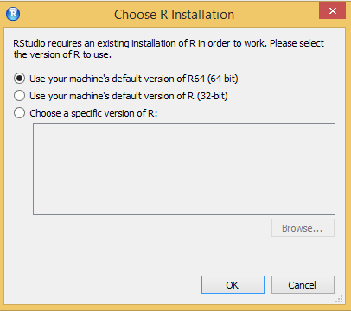

If RStudio detects that R hasn’t been installed on your system, it will show you a warning.
If R has been installed, you’ll see the R Studio interface. In the beginning, you can only see the R console where you can write one line statements in R and execute them.
However, even for trivial work, you will need to perform a sequence of steps and it is better to create an R script.
Go to File > New File > R Script as shown in the screenshot below to create a new R script.
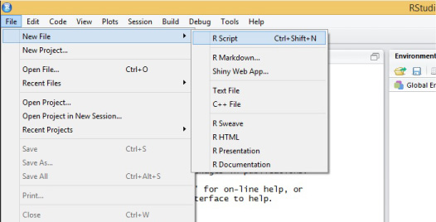
You can now see the R Script Editor where you can type and save R programs that span multiple lines. RStudio isn’t just a text editor but an IDE that helps you run and debug R scripts with ease.
The R Studio GUI is divided into 4 major sections as shown in the screenshot below:
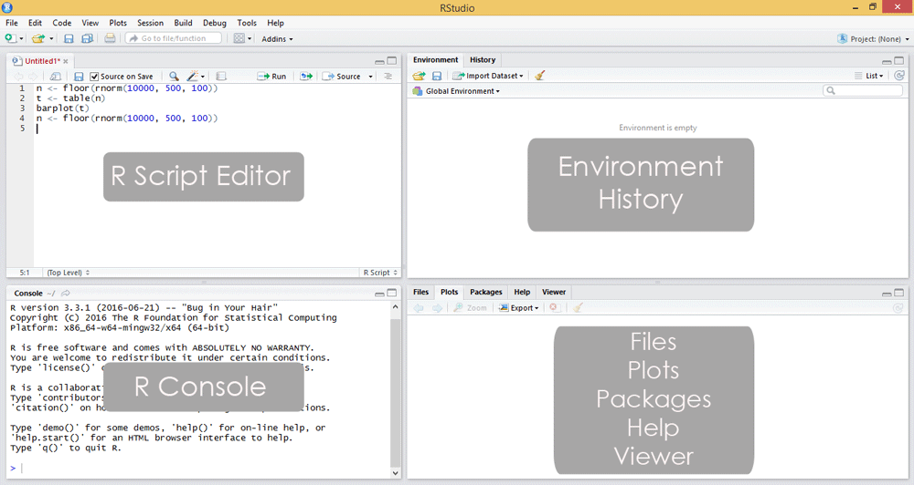

IDE Areas
Let’s briefly explain the GUI. There are four main parts.The explanation is given in the default order, though note that this can be changed in Settings/Preferences -> Pane Layout.

The Editor(R Script Editor)
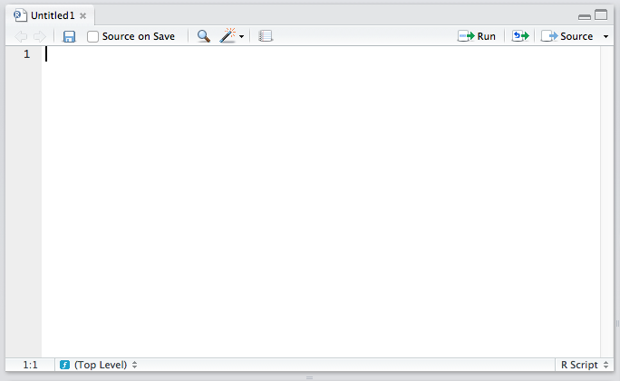
The top left quadrant is the editor. It’s where you write R code you want to keep for later – functions, classes, packages, etc. This is, for all intents and purposes, identical to every other code editor’s main window. Apart from some self-explanatory buttons, and others , there is also a “Source on Save” checkbox. This means “Load contents of file into my console’s runtime every time I save the file”. You should have this on at all times, it makes your development flow faster by one click.

The Console(R Console)
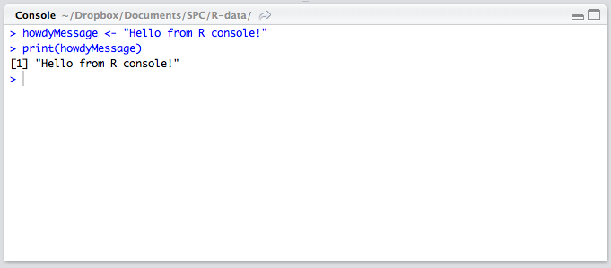
To begin with R, one needs to start working with R console where all the action takes place.
The lower left quadrant is the console. It’s a REPL (Read–Eval–Print Loop) for R in which you can test out your ideas, datasets, filters, and functions. This is where you’ll be spending most of your time in the beginning – it’s here that you verify an idea you had works before copying it over into the editor above. This is also the environment into which your R files will be sourced on Save (see above), so whenever you develop a new function in an R file above, it automatically becomes available in this REPL.
In other words , R console is an execution window where users can execute R commands . Users need to type the required action on the command prompt and upon pressing the Enter key , R interprets the action typed by the user , executes the same , and gives the answer.

Note : To get help for data frames type ?data.frame in the console.

History / Environment
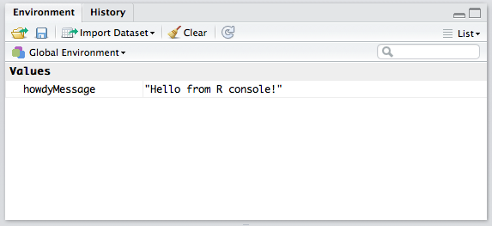
The top right quadrant has two tabs: environment and history.
Environment refers to the console environment (see above) and will list, in detail, every single symbol you defined in the console (whether via sourcing or directly). That is, if you have a function available in the REPL, it will be listed in the environment. If you have a variable, or a dataset, it will be listed there. This is where you can also import custom datasets manually and make them instantly available in the console, if you don’t feel like typing out the commands to do so. You can also inspect the environment of other packages you installed and loaded.
History lists every single console command you executed since the last project started. It is saved into a hidden .Rhistory file in your project’s folder. If you don’t choose to save your environment after a session, the history won’t be saved.

Misc(Files,Plots,Packages,Help,Viewer)
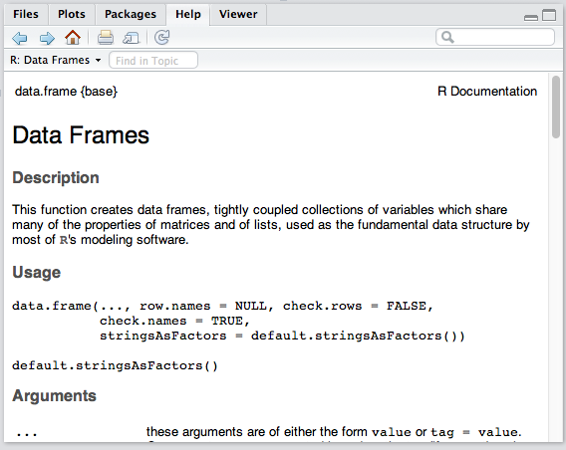
The bottom right panel is the misc panel, and contains five separate tabs. The first one, Files, is self-explanatory. The Plots tab will contain the graphs you generated with R. It is there you can zoom, export, configure and inspect your charts and plots. The Packages tab lets you install additional packages into R.
The Help tab lets you search the incredibly extensive help directory and will automatically open whenever you call help on a command in the console (help is called by prepending a command name with a question mark, like so: ?data.frame).
Finally, the Viewer is essentially RStudio’s built-in browser. You can develop web apps with R and even launch locally hosted web apps within it.

1.BASIC OPERATIONS IN R

Assignment & Evaluation
Assignment
The first operator you’ll run into is the assignment operator. The assignment operator is used to assign a value. For instance we can assign the value 3 to the variable x using the <- assignment operator.
# assignment
x <- 3
Interestingly, R actually allows for five assignment operators:
# leftward assignment
x <- value
x = value
x <<- value
# rightward assignment
value -> x
value ->> x
The original assignment operator in R was <- and has continued to be the preferred among R users. The = assignment operator was added in 2001 primarily because it is the accepted assignment operator in many other languages and beginners to R coming from other languages were so prone to use it. However, R uses = to associate function arguments with values (i.e. f(x = 3) explicitly means to call function f and set the argument x to 3. Consequently, most R programmers prefer to keep = reserved for argument association and use <- for assignment.

The operators <<- is normally only used in functions which we will not get into the details. And the rightward assignment operators perform the same as their leftward counterparts, they just assign the value in an opposite direction.

Overwhelmed yet? Don’t be. This is just meant to show you that there are options and you will likely come across them sooner or later. My suggestion is to stick with the tried and true <- operator. This is the most conventional assignment operator used and is what you will find in all the base R source code…which means it should be good enough for you.

Evaluation
We can then evaluate the variable by simply typing x at the command line which will return the value of x. Note that prior to the value returned you’ll see ## [1] in the command line. This simply implies that the output returned is the first output. Note that you can type any comments in your code by preceding the comment with the hash tag (#) symbol. Any values, symbols, and texts following # will not be evaluated.
# evaluation
x
## [1] 3
Case Sensitivity
Lastly, note that R is a case sensitive programming language. Meaning all variables, functions, and objects must be called by their exact spelling:

x <- 1
y <- 3
z <- 4
x * y * z
## [1] 12

x * Y * z
## Error in eval(expr, envir, enclos): object 'Y' not found

BASIC ARITHMETIC OPERATIONS
At its most basic function R can be used as a calculator. When applying basic arithmetic, the PEMDAS order of operations applies: parentheses first followed by exponentiation, multiplication and division, and final addition and subtraction.

8 + 9 / 5 ^ 2
## [1] 8.36

8 + 9 / (5 ^ 2)
## [1] 8.36

8 + (9 / 5) ^ 2
## [1] 11.24

(8 + 9) / 5 ^ 2
## [1] 0.68
By default R will display seven digits but this can be changed using options() as previously outlined.

1 / 7
## [1] 0.1428571

options(digits = 3)
1 / 7
## [1] 0.143
Also, large numbers will be expressed in scientific notation which can also be adjusted using options().

888888 * 888888
## [1] 7.9e+11

options(digits = 10)
888888 * 888888
## [1] 790121876544
Note that the largest number of digits that can be displayed is 22. Requesting any larger number of digits will result in an error message.

pi
## [1] 3.141592654
options(digits = 22)
pi
## [1] 3.141592653589793115998

options(digits = 23)
## Error in options(digits = 23): invalid 'digits' parameter, allowed 0...22
pi
## [1] 3.141592653589793115998
We can also perform integer divide (%/%) and modulo (%%) functions. The integer divide function will give the integer part of a fraction while the modulo will provide the remainder.

42 / 4 # regular division
## [1] 10.5

42 %/% 4 # integer division
## [1] 10

42 %% 4 # modulo (remainder)
## [1] 2
Miscellaneous Mathematical Functions
There are many built-in functions to be aware of. These include but are not limited to the following. Go ahead and run this code in your console.

x <- 10

abs(x) # absolute value
sqrt(x) # square root
exp(x) # exponential transformation
log(x) # logarithmic transformation
cos(x) # cosine and other trigonometric functions
Infinite, and NaN Numbers
When performing undefined calculations, R will produce Inf (infinity) and NaN (not a number) outputs.

1 / 0 # infinity
## [1] Inf
Inf - Inf # infinity minus infinity
## [1] NaN
-1 / 0 # negative infinity
## [1] -Inf
0 / 0 # not a number
## [1] NaN
sqrt(-9) # square root of -9
## Warning in sqrt(-9): NaNs produced
## [1] NaN

VECTOR ARITHMETIC:
R perform element wise element arithmetic operations
Consider two vectors a and b.Vector arithmetic operations can be performed as follows,
a=c(1,2,3,4,5,6)
b=c(3,4,5,6,7,8)
Vector Addition
a+b
[1] 4 6 8 10 12 14
Vector Subtraction
a-b
[1] -2 -2 -2 -2 -2 -2
Vector Multiplication
a*b
[1] 3 8 15 24 35 48
Vector division
a/b
[1] 0.3333333 0.5000000 0.6000000 0.6666667 0.7142857 0.7500000

Exercise:
1.Write The Commands To Perform Basic Arithmetic In R.
2. Display a String on R Console.
3. Declare Variables In R And Also Write The Commands For Retrieving The Value Of The Stored Variables In R Console.
4. Write R script to calculate the area of Rectangle.
5.Write Commands In R Console To Determine The Type Of Variable
6.Enumerate The Process To Check Whether A Given Input Is Numeric , Integer , Double, Complex in R.
7. Illustration of Vector Arithmetic.
8. Write an R Program to Take Input From User.
Input name as “Jack” and age as 17.
The program should display the output as
“Hai , Jack next year you will be 18 years old”

2.DATA STRUCTURES IN R
R is an object oriented language. Everything in R is an object. When R does anything, it creates and manipulates objects.
R’s objects come in different types and flavors.
The most basic ones are:
• Vectors
• Lists
• Matrices
• Arrays
• Factors
• Data Frames

- VECTORS
Vectors are the most basic data objects / data structure in R. A vector is a sequence of data elements of the same data type. Vector can be created using c(),seq(),:
- LISTS
A list is an R-object which can contain many different types of elements inside it like vectors, functions and even another list inside it.Lists are like vectors but they do not have to contain elements of the same mode. The first element of a list could be a vector of the 26 letters of the alphabet. The second element could contain a vector of all the prime numbers below 1000. A third could be a 2 by 7 matrix. List is created using list().
- MATRICES
Matrices are vectors with a dimension attribute. The dimension attribute is itself an integer vector oflength 2 (nrow, ncol). Matrices can be created with matrix() function and also by column-binding or row-binding with cbind() and rbind().
- ARRAY
While matrices are confined to two dimensions, arrays can be of any number of dimensions. The array() function takes a dim attribute which creates the required number of dimension. In the below example we create an array with two elements which are 3x3 matrices each.
5.Factors
Factors are vectors to classify categorical data. Factors are the r-objects which are created using a vector.
Factors are created using the factor() function. The nlevels functions gives the count of levels.
6. DATAFRAMES
Data frames are used to store tabular data.Data Frames are created using the data.frame() function.
CLASS
Everything in R language is considered as an object and every object is associated with a class. We can create a class in R using the class keyword. While most programming languages have a single class system, R has three class systems namely, S3, S4 and more recently Reference class systems.
Exercise:
1) Perform Matrix Addition & Subtraction in R
2) Perform Scalar multiplication and matrix multiplication in R
3) Find Transpose of matrix in R.
4) Perform the operation of combining matrices in R using cbind() and rbind() functions.
5) Deconstruct a matrix in R
6) Perform array manipulation in R .
7) Perform calculations across array elements in an array using the apply() function.
8) Demonstrate Factor data structure in R.
9) Create a data frame and print the structure of the data frame in R.
10) Demonstrate the creation of S3 class in R.
11) Demonstrate the creation of S4 class in R.
12) Demonstrate the creation of Reference class in R by defining a class called students with fields – Name, Age , GPA. Also illustrate how the fields of the object can be accessed using the $ operator. Modify the Name field by reassigning the name to Paul.

